# ASSIGNMENT 2.2:-

Step 1&2:- 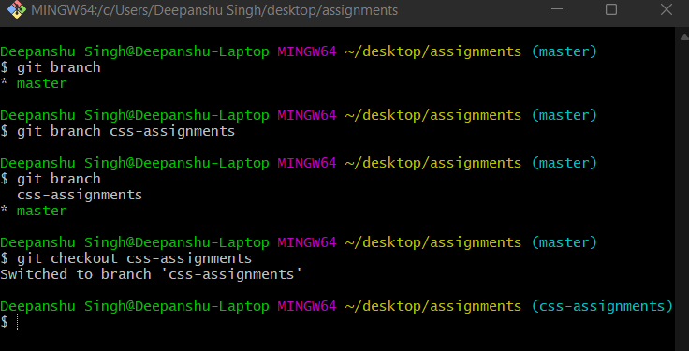

Step 3&4:- 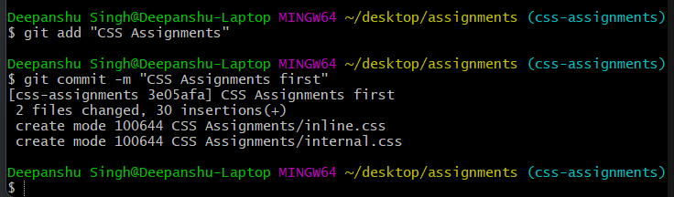

Step 5 to 7:- 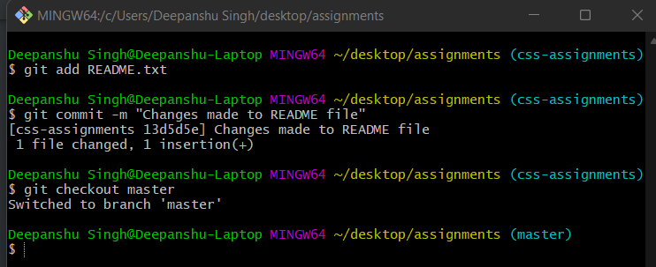

Step 8:- 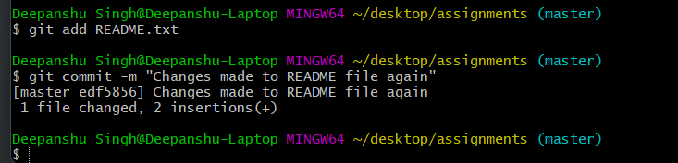

Step 9:- 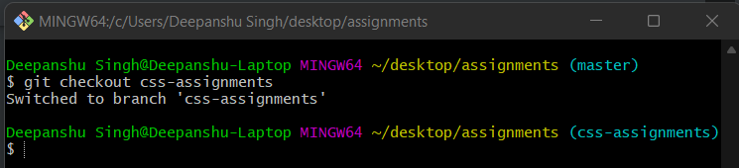

Step 10 to 12:- 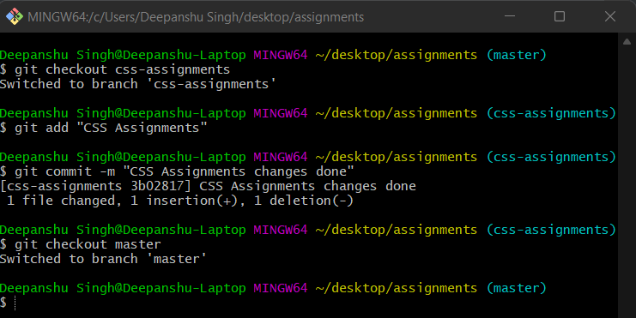

Step 13:- 

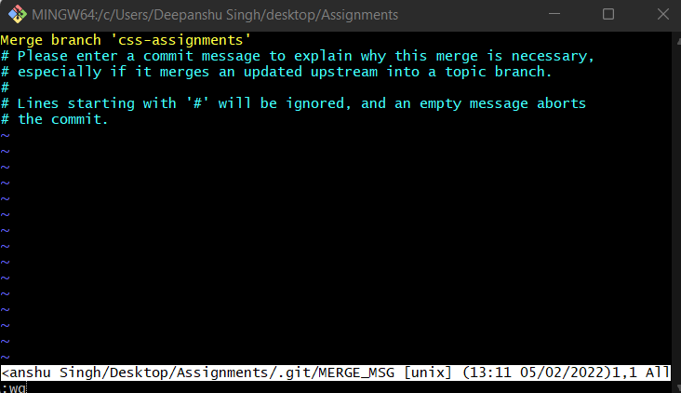

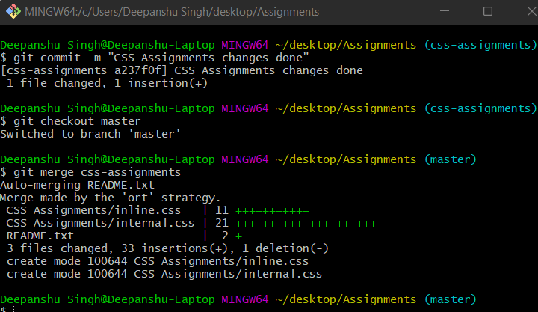

Step 14:- 